[Course Number]
[Course Name]
Assignment 4: Service Standards (Frequency and Reliability)
Assigned: [Assigned Date]
Due: [Due Date]

Instructions
This assignment provides you with experience evaluating a high frequency bus route. You should work individually for this assignment. Submit a 2 page report (maximum) answering the 5 questions via the class website and also upload an Excel spreadsheet showing your calculations to the class website.

Dataset
You have been asked to conduct an analysis of a high frequency bus route. Manual data collection on this bus route has already been conducted, and the data are in an Excel file showing the observed headways at a single stop on the route during the AM peak period (7am until 9am) for 5 weekdays. The scheduled headway during the AM peak period is 6 minutes. The dataset includes 100 observations with observed headways ranging from 1 minute to 15 minutes. The complete dataset is available on the class website.

Questions
- Using the data in the “January_Data” worksheet, calculate the mean, standard deviation, and coefficient of variation (c_{vh}) for the observed headways. Please round your answers to two digits after the decimal place (example: 6.00). The coefficient of variation of headways is also known as the schedule adherence. Compare your calculated coefficient of variation to the values in the TCQSM (shown below) and briefly discuss it. (Note: if you are using Excel, use the “STDEVP” function, which is for an entire population.)

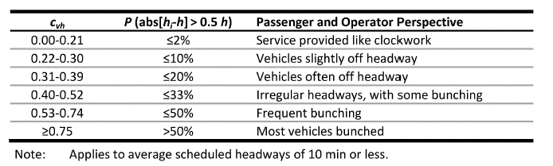
Figure 1: TCQSM Chapter 5 Page 5-31
- Because this is high frequency bus service, we assume that passengers arrive at this bus stop randomly and can calculate the “expected wait time” (t_{w}). Calculate the expected passenger wait time, and compare this to the scheduled passenger waiting time (i.e. half of the scheduled headway) for the “January_Data.”

- Because many measures of service reliability can be difficult to explain to passengers (e.g. coefficient of variation), you propose a new service standard that focuses on “big gaps” in bus service. You propose that no more than 10% of passengers should have to wait more than H+2 minutes, where H is the scheduled headway (6 minutes). Assuming equal passenger boardings on all observed trips, does your route meet this service standard? To answer this question, determine the percentage of observed headways that meet the standard for the “January_Data.” Please round your answer to the nearest whole percent.

- After reviewing the results of your January analysis, the transit agency implemented a number of real-time control strategies to improve reliability on this route. Then, additional headway data were collected (“February_Data”) for the same route, again during the AM peak period on five weekdays. You are asked to evaluate if the control strategies were successful in improving reliability on the route. To answer this question, calculate the mean, standard deviation, and coefficient of variation (c_{vh}) for the observed headways. Please round your answers to two digits after the decimal place (example: 6.00). Compare the schedule adherence to your answer from question 1 and briefly discuss the implications.

- Determine if the new real-time control strategies helped reduce the number of “big gaps” on this route. To answer this question, calculate the percentage of observed headways that meet the standard of H+2 minutes. Please round your answer to the nearest whole percent. Compare this to your answer from question 3.

Reference: This homework is adapted from Professor Peter Furth at Northeastern University. This dataset has been made up for the purpose of this assignment.

