[Course Number]
[Course Name]
Assignment 3: Station Capacity and Planning – Ticketing Facilities
Assigned: [Assigned Date]
Due: [Due Date]

Instructions
This assignment pertains to planning new rail stations. You should work individually for this assignment. Submit a 2 page report (maximum) answering the 5 questions. Please also upload an Excel spreadsheet showing your calculations to the course website.

Background
Transport for London (TfL) is building a major new rail line under central London. The project, known as Crossrail, is one of the largest infrastructure projects ever undertaken in the United Kingdom. Crossrail includes construction of numerous new stations that will require tunneling underground in central London. For this assignment, consider 8 of the new stations: Paddington, Tottenham Court Road, Liverpool Street, Isle of Dogs/Canary Wharf, Bond Street, Farringdon, Whitechapel and Woolwich (see map on following page).

You work as a transit planner on a team that is designing the 8 underground Crossrail stations. Your role on the team is to determine the ticketing facility requirements for these stations. This is particularly important since space is at a premium in these underground stations (tunneling is expensive!). Your three tasks are to determine (1) the number of ticket vending machines in each station, (2) the number of faregates in each station, and (3) the number of escalators needed to reach the ticket hall in each station.

Data
You are provided with two datasets that can be found on the course website. The first dataset is from the Travel Demand Modeling Team at TfL, and it includes projections of peak hour passenger entries at each of the 8 underground Crossrail stations for the AM and PM peak hours. The second dataset includes manually collected observations of transaction times at ticketing vending machines (TVMs) in existing rail stations in central London. Transaction time is defined as the total time (in seconds) that it takes a passenger to purchase a paper ticket or load value onto a smartcard at a TVM.

Questions
- Transaction Times: Calculate the mean, median, minimum, maximum, and 75th percentile transaction times at the ticket vending machines (TVMs). Briefly comment on these values. What type of passengers might be associated with the minimum, mean, and maximum values?

- Fare Purchases: Based on the AM and PM peak hour passenger entries, determine the number of TVMs needed at each of the 8 underground Crossrail stations using the TCQSM methodology. Assume that 20% of passengers entering the station purchase a ticket or load a smartcard at the TVMs. (Please round up to the nearest whole number, since the number of ticket vending machines must be an integer.)

- New Fare Payment System: TfL has recently upgraded their smartcard fare collection system to accept contactless credit and debit cards directly at faregates in rail stations. This means that riders do not need to visit transit vending machines before riding the train; instead, they can simply tap their contactless credit or debit card at the faregates, and the fare is automatically billed to their account. You estimate that by the time Crossrail stations open, this new fare payment technology will reduce the number of passengers purchasing a ticket or loading a smartcard at TVMs from 20% to only 5%. If each TVM costs $75,000 (or £50,000), how much would the capital costs of TVMs be reduced (as compared to your answer from the previous question)?

- Fare Control: Determine the number of faregates (turnstiles) needed in each of the 8 underground Crossrail stations using the methodology outlined in the TCQSM. All faregates are high bi-leaf gates. Assume that the peak 15 minute period has 35% of the peak hour demand. Also assume that there will be 2 additional gates designated specifically for reverse flow at each station. (Please round up to the nearest whole number, since the number of faregates must be an integer.)

- Number of Escalators: To reach the TVMs and enter the faregates, passengers proceed from street level, down escalators, and into the ticket hall (where the TVMs and faregates are located). Using the TCQSM methodology, calculate the number of escalators needed to serve passengers entering each of the 8 underground Crossrail stations. Assume that all escalators will be double-wide with incline speeds of 90 ft/min and that the peak 15 minute period has 35% of the peak hour passenger entries. Do not worry about escalators for passengers exiting the station. (Please round up to the nearest whole number, since the number of escalators must be an integer.)

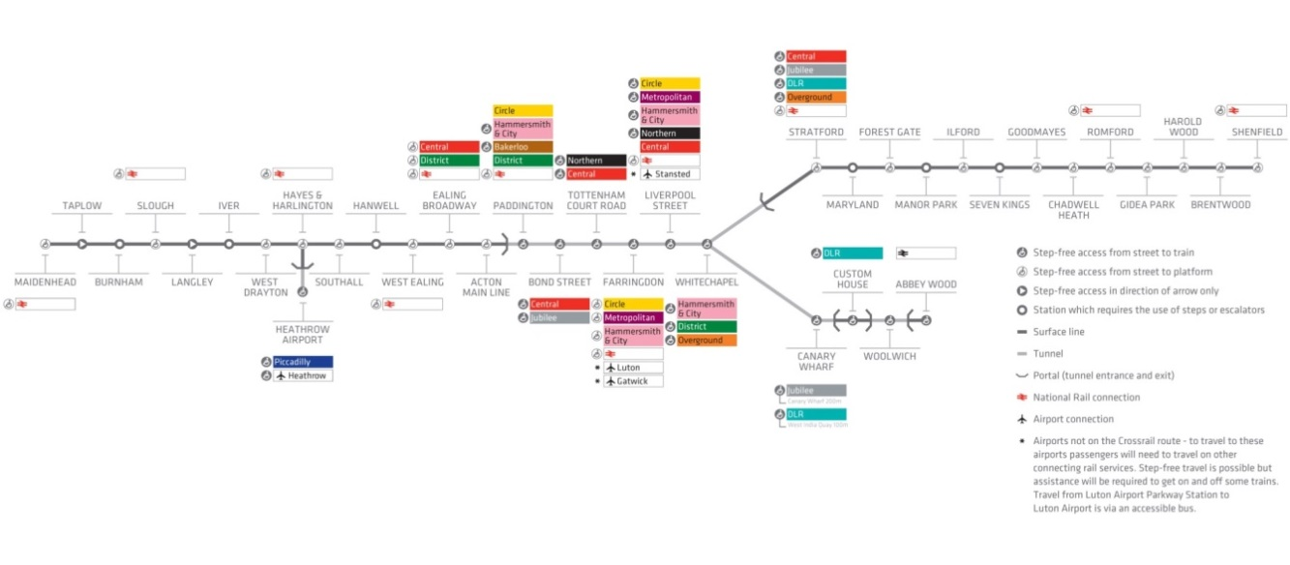

For more information on Crossrail, see: http://www.crossrail.co.uk/

