**[Course Number]**

**[Course Name]**

**Participation Exercise: Frequency Determination**

Name:___________________________

Date:____________________________

**Please answer the questions below.**

*Refer to the single load profile diagram for the 8-9am hour. Assume that the desired vehicle occupancy is 50 passengers and that the (maximum) vehicle capacity is 90 passengers. The total route length is 10 km.*

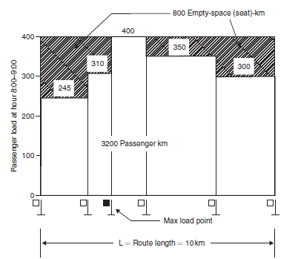

8am -9am-9am



1. What is the total area in passenger-km?__________________________________________

__________________________________________________________________________

__________________________________________________________________________

1. What is the volume at the hourly maximum load point? _____________________________
2. Based on Option 1 (method 3), what should the frequency be (vehicles/hour)? ___________

__________________________________________________________________________

1. Based on Option 2 (method 3), what should the frequency be (vehicles/hour)? ___________

__________________________________________________________________________

1. Which is larger? Option 1 or 2? ________________________________________________