[Course Number]
[Course Name]

Participation Exercise: Bus Capacity

Name:___________________________

Date:____________________________

Please solve the following numerical problem.

A transit route has 8 total bus stops. The critical bus stop is Stop #3, which is an online stop located at the near-side of a signalized intersection. The following information is known about the bus route:
- Dwell time at critical stop = 40 seconds
- Clearance time at Stop #3 = 10 seconds
- Coefficient of variation for dwell times is 60%
- The signal at Stop #3 has a cycle length of 90 seconds, and the bus approach has 40 seconds of green time per cycle.
- The acceptable failure rate is 7.5%

You may find the following table from TCQSM page 6-65 helpful.
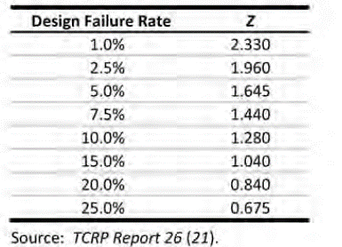

Determine the bus load area capacity. Please show your supporting calculations.

Acknowledgements: This problem has been adapted from Dr. Alison Conway at CCNY.

